

Daily report on WIT & WIL Date: 6-3-19 & 7-3-19

Name of the faculty: Dr.K.Padmaja Name of the subject: Engineering Chemistry
Class/ Section: I B.Tech II sem CSE – B
1 | Grid Reference No : | 3.3
2 | Scenario Reference: | 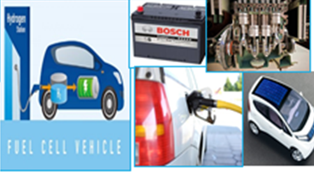
3 | Topic Covered: | Batteries –Solar cell and Fuel cell
4 | Brief Write – up (500 words):  Description of the how the topic (Mentioned in point: 3) is mapped with the scenario (mentioned in point : 2) is given.  Solar cell and Fuel cells are used in running cars.These are ecofriendly and choice for future cars.  A solar cell, or photovoltaic cell, is an electrical device that converts the energy of light directly into electricity by the photoelectric effect.  A fuel cell is a device that converts the chemical energy from a fuel into electricity through a chemical reaction with oxygen or another oxidizing agent. The voltage is usually between 0.5 and 1.0 volts DC (direct current).Several fuel cells are connected together in series to obtain higher voltages 25—100 volts.  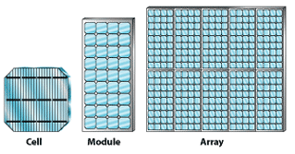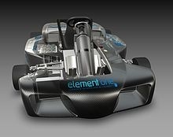  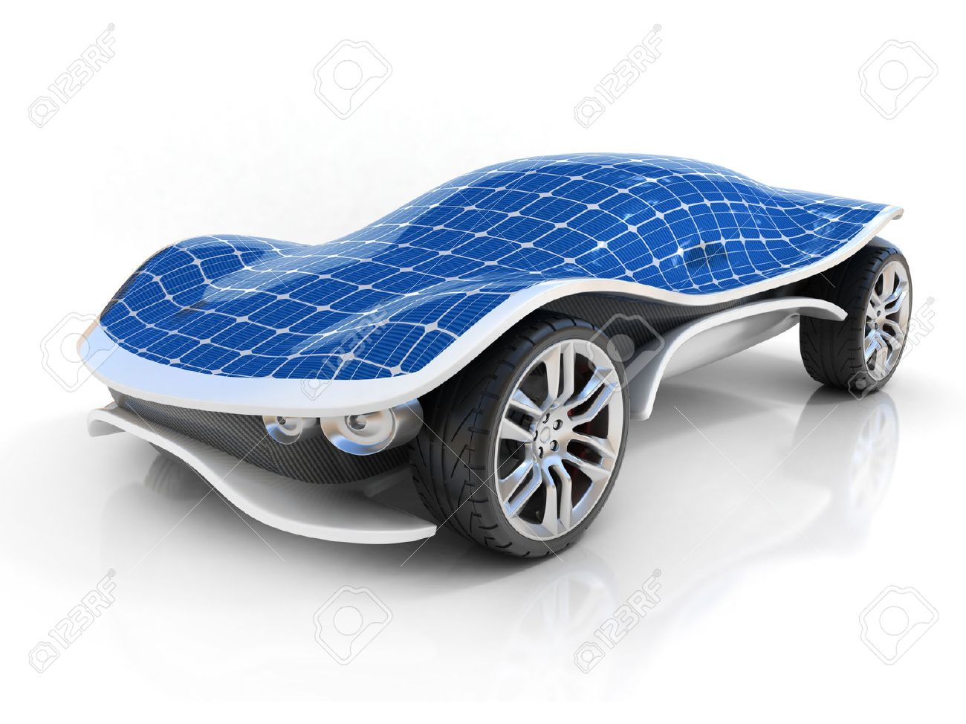
5 | Relevant additional illustration if any: Fuel Cells And solar cells applications in different fields  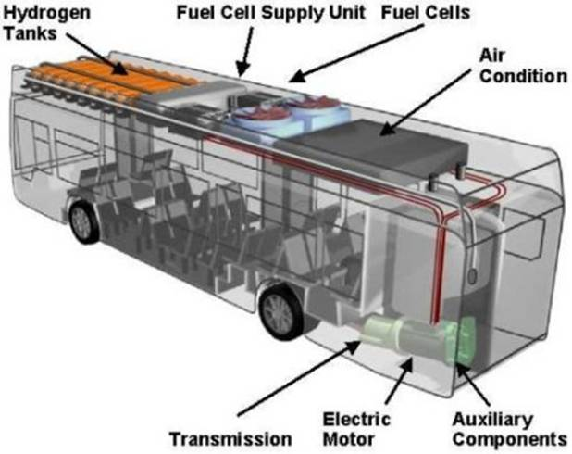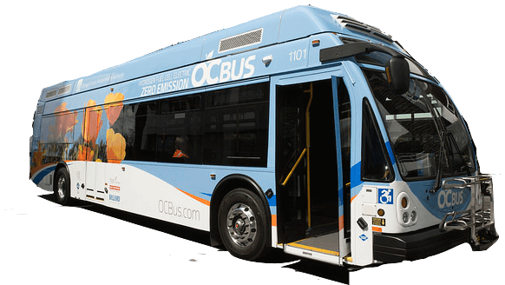  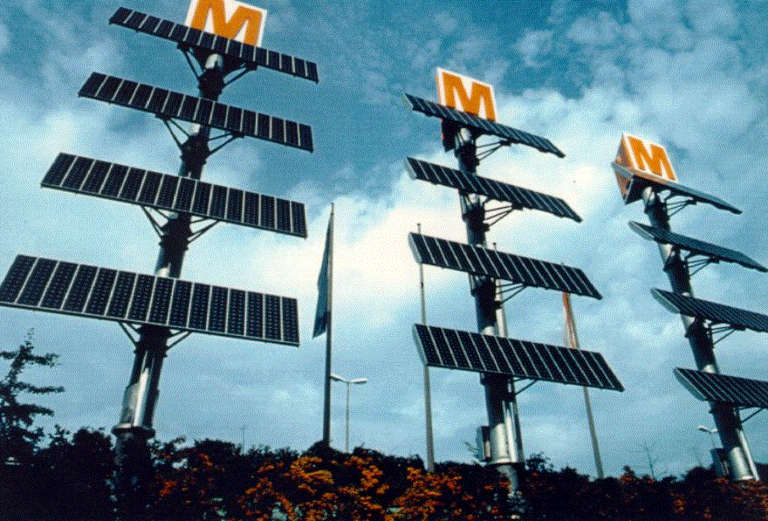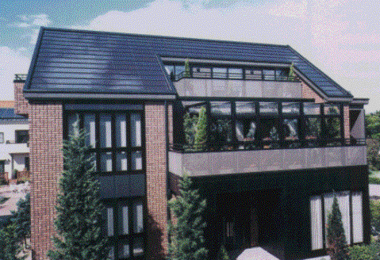
6 | Video links / web links if any: |  | Give video / web links : https://www.youtube.com/watch?v=qng8NZ7iwN8 https://www.youtube.com/watch?v=ZYO83TkM0To
7 | Signature of Repository Administrator:

